11th International Conference on Sensitivity Analysis of Model Output, April 23-25 2025, Grenoble, France

Sensitivity analysis of multi-scale energy power system models

STEFANO TARANTOLA,

Joint Research Centre - Directorate for Energy, Mobility and Climate, Ispra (Italy)

MIRKO GINOCCHI

RWTH Aachen University, 52064 Aachen (Germany)

SERGEI KUCHERENKO

Imperial College London (United Kingdom)

ROSSANA ROSATI

Joint Research Centre - Science for Modelling, Monitoring and Evaluation, Ispra (Italy)

This paper describes an application of global sensitivity analysis (GSA) in the context of energy power systems modelling. In this application, a multi-scale system is considered, where an overarching model describing the system integrates smaller models that represent various components of that system.
We refer to the overall model as the “macro-model”, and the individual component models as “micro-models”. Notably, macro-models can be significantly more computationally intensive to solve than their corresponding micro-models.
This study explores the relationship between the Sobol’ total sensitivity indices of the micro- and macro-models, specifically within the framework of fixing certain factors to potentially reduce the complexity of the macro-model through GSA on the micro-models [1].
Consider the following set-up, where two micro-models $g$ and $h$ are functions of subsets of input factors $\vec{x}$ and $\vec{y}$, respectively:
$$z_{1}=g\left(\vec{x}\right),\vec{x}∈R^{n},\left(1a\right)$$
$$z_{2}=h\left(\vec{y}\right),\vec{y}∈R^{m}\left(1b\right)$$
The combined macro-model is expressed as:
$$w=f\left(z_{1},z_{2}\right).\left(2\right)$$
This macro-model can also be represented as a function of the input vectors $\vec{x}$ and $\vec{y}$:
$$w=f\left(g\left(\vec{x}\right),h\left(\vec{y}\right)\right)=f\left(\vec{x},\vec{y}\right).\left(3\right)$$
We assume that $\vec{x}$ and $\vec{y}$ are two uncorrelated random vectors with known probability density functions. The authors in [1] demonstrate that a relationship exists between the Sobol’ total sensitivity indices $T_{x_{i}}^{g}$ and $T_{y_{i}}^{h}$of the micro-models (1a) and (1b), and the indices $T_{x_{i}}^{f}$ and $T_{y_{i}}^{f}$ of the macro-model (3). For certain classes of functions, it can be proven that:
$T_{x_{i}}^{f}≤T_{x_{i}}^{g}$ and $T_{y_{i}}^{f}≤T_{y_{i}}^{h}$ (4)
If the estimated total sensitivity indices for $g$ and $h$ are found to be small, then, according to (4), the indices of $f$ will be even smaller. Consequently, by performing GSA only on the micro-models, it is possible to reduce the dimensionality of the macro-model by fixing the input(s) with small total sensitivity indices at a specific value $x_{i}^{0}$ (equivalently, $y_{i}^{0}$). This would lead to an approximation error $δ\left(x_{i}^{0}\right)$ such that $Eδ\left(x_{i}^{0}\right)=2T_{x_{i}}^{f}$ (see [2]), where:
$δ\left(x_{i}^{0}\right)=\frac{\int{{\left[f\left(x,y\right)−f\left(x_{ i},x_{i}^{0},y\right)\right]}^{2}dxdy}}{Var\left(w\right)}$ (5)
The approach proposed in [1] is successfully tested on a case study in the domain of power energy systems. The case study aims at evaluating the performance of a protection relay designed to interrupt the flow of current along the circuit when a fault occurs in a 54-km high-voltage submarine transmission line (see Figure 1). The relay is supposed to determine the fault location with satisfactory accuracy so to put in place the necessary countermeasures for quickly clearing the fault and restoring the power supply. If the relay performs well, then the fault location is determined with small uncertainty. It is evident that accurately estimating the location of the fault is crucial, as the time to find and repair the fault becomes critical.
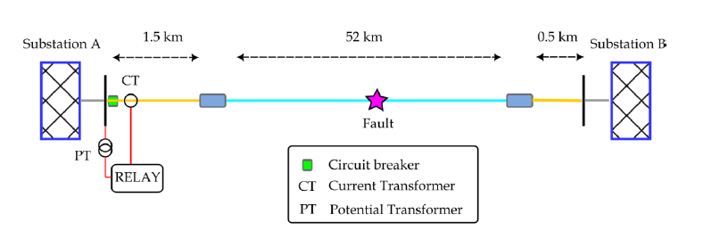
Figure 1: Schematic representation of the transmission power system under study
The metric used for assessing the relay performance, specifically the output of the macro-model, is the fault location error 𝜀, defined as the difference between the actual fault location 𝑚 and the location $\hat{m}$ recorded by the relay:
$ε=m−\hat{m}$ (6)
The input factors are uncertain parameters related to the cross-section and the geometry of the cables.
GSA conducted solely on the micro-models reliably indicates that the output of the macro-model (i.e., the fault location error) is not sensitive to 23 out of the 34 inputs; these can be fixed at any value within their range of variation with the aim of model simplification. Furthermore, GSA reveals additional features of the model.
Applying this comprehensive methodology to the exemplary case study offers practical insights and general guidance on how to adapt the methodology for exploring alternative system models.
References
[1] A. Nikishova, G.E. Comi, A.G. Hoekstra “Sensitivity analysis based dimension reduction of multiscale models”. Mathematics and Computers in Simulation, (170):205-220, 2020
[2] I.M. Sobol’, S. Tarantola, D. Gatelli, S. Kucherenko, W. Mauntz. “Estimating the Approximation Error when fixing Unessential Factors in Global Sensitivity Analysis”, Reliability Engineering & System Safety, 92(7):957-960, 2007.

[ Stefano Tarantola; Joint Research Centre - Directorate for Energy, Mobility and Climate, Ispra (Italy) ]
[Stefano.tarantola@ec.europa.eu-https://joint-research-centre.ec.europa.eu]

